Linear Regression with OLS:

OLS: Ordinary Least Square

We will be implementing Linear Regression using OLS

We have previously seen how to implement Linear Regression using gradient descent

OLS tells us how we can apply formula and calculate $β_{0}$ and $β_{1}$.

Aim: To reduce the error between the predicted value and the truth value with respect to any best fit line that we create.

Ordinary Least Square:

Considering best fit line to be given as $h_{θ}\left(x\right)= β_{0} + β_{1} x_{1}$

$S(β_{0}$, $β_{1})= \frac{1}{n}\sum_{i=1}^{n}{{(y_{i}-(β_{0} + β_{1} x_{1}))}^{2}}$

OLS by default uses MSE

We want to find the formula for $β_{0}$ and $β_{1}$.

$\frac{∂S (β_{0}, β_{1})}{∂β_{0} }= -\frac{2}{n} \sum_{i=1}^{n}{{\left(y_{i}-\left(β_{0} + β_{1} x_{1}\right)\right)}^{1}}$-> (i)

$\frac{∂S (β_{0}, β_{1})}{∂β_{1} }= -\frac{2}{n} \sum_{i=1}^{n}{{\left(y_{i}-\left(β_{0} + β_{1} x_{i}\right)\right)}^{1}( x_{i})}$-> (ii)

Taking equation (i)

$-\frac{2}{n} \sum_{i=1}^{n}{{\left(y_{i}-\left(β_{0} + β_{1} x_{1}\right)\right)}^{1}}=0$

$-\sum_{i=1}^{n}{{\left(y_{i}-\left(β_{0} + β_{1} x_{1}\right)\right)}^{1}}=0$

Distributing the summation, we get:

$-\sum_{i=1}^{n}{y_{i}}+ {nβ}_{0} + β_{1}\sum_{i=1}^{n}{x_{i}}=0$

${nβ}_{0} + β_{1}\sum_{i=1}^{n}{x_{i}}=\sum_{i=1}^{n}{y_{i}}$

$β_{0} =\frac{\sum_{i=1}^{n}{y_{i} }- β_{1}\sum_{i=1}^{n}{x_{i}} }{n}$

Intercept formula:

$β_{0}= \overline{y}- β_{1}\overline{x}$

Now taking equation (ii):

$-\frac{2}{n} \sum_{i=1}^{n}{{\left(y_{i}-\left(β_{0} + β_{1} x_{1}\right)\right)}^{1}\left( x_{i}\right)}=0$

$\sum_{i=1}^{n}{{\left(y_{i}-\left(β_{0} + β_{1} x_{1}\right)\right)}^{1}( x_{i})}$ = 0

$\sum_{i=1}^{n}{y_{i}x_{i}- }β_{0}\sum_{i=1}^{n}{x_{i}- β_{1}{(x_{i})}^{2}} = 0$

$\sum_{i=1}^{n}{{(y}_{i}x_{i}- }β_{0}x_{i}- β_{1}{\left(x_{i}\right)}^{2}) = 0$

We already know the value of $β_{0}$, substituting it’s value

$\sum_{i=1}^{n}{{(y}_{i}x_{i}- }(\overline{y}- β_{1}\overline{x} )x_{i}- β_{1}{\left(x_{i}\right)}^{2}) = 0$

$\sum_{i=1}^{n}{{(y}_{i}x_{i}- }x_{i}\overline{y}- β_{1}\overline{x}x_{i}- β_{1}{\left(x_{i}\right)}^{2}) = 0$

Taking $x_{i}$ common,

$\sum_{i=1}^{n}{{(y}_{i}- }\overline{y}- β_{1}\overline{x}- β_{1}{\left(x_{i}\right)}^{1}) x_{i} = 0$

$\sum_{i=1}^{n}{{(y}_{i}- }\overline{y}- β_{1}\overline{x}- β_{1}{\left(x_{i}\right)}^{1}) = 0$

$\sum_{i=1}^{n}{{(y}_{i}- }\overline{y}+ β_{1}(\overline{x}- x_{i})) = 0$

$\sum_{i=1}^{n}{{(y}_{i}- }\overline{y})+ \sum_{i=1}^{n}{β_{1}(\overline{x}- x_{i}) }=0$

$\sum_{i=1}^{n}{β_{1}(\overline{x}- x_{i}) }=-\sum_{i=1}^{n}{{(y}_{i}- }\overline{y})$

$β_{1}= -\frac{\sum_{i=1}^{n}{{(y}_{i}- }\overline{y}) }{\sum_{i=1}^{n}{(\overline{x}- x_{i}) }}$

$β_{1}= \frac{-\sum_{i=1}^{n}{{(y}_{i}- }\overline{y}) }{-\sum_{i=1}^{n}{( x_{i}-\overline{x}) }}$

Coefficient formula:

$β_{1}= \frac{\sum_{i=1}^{n}{{(y}_{i}- }\overline{y}) }{\sum_{i=1}^{n}{( x_{i}-\overline{x}) }}$

We will have a dataset, x and y features, so we can calculate $\overline{x}$ and $\overline{y}$

We can then calculate $β_{1}$ followed by $β_{0}$

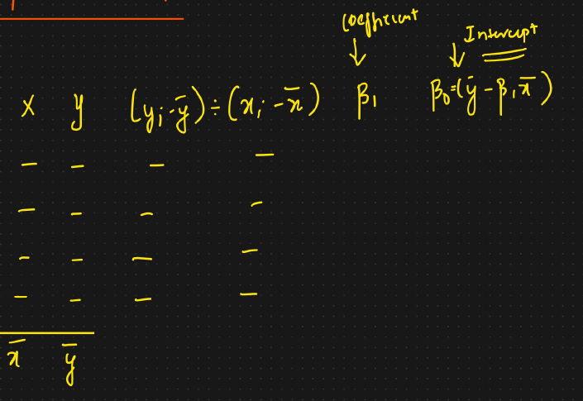

This is for simple linear regression.

In multiple linear regression, the equation will change.

OLS will give approximately the same value as compared to Simple Linear Regression using SKlearn